**Quantum Simulation and Dynamics**

**Universal Heisenberg model Hamiltonian for three interacting atoms**

**(Dated: May-16-2022)**

[**Rajat Kumar Vishwakarma**](mailto:rjvishwa709@gmail.com)

**University of Allahabad.**

**Department of Quantum Physics.**

**211013 prayagraj india.**

**Source Code: [**[**https://github.com/rajat709/Quantum-Simulation**](https://github.com/rajat709/Quantum-Simulation)**]**

**Today Quantum Computers have a wide range of applications, one of the prominent is quantum simulation. Simulations are used for many industrial and research purposes. Here we understand how can we simulate three atoms heisenberg model interaction on three qubits using real NISQ(Noisy Intermediate-Scale Quantum Computing) device ‘ibmq\_jakarta’ first we perform simulation by classical method after that we will go on quantum approach,for 3 qubit simulation its represented by 8×8 matrix. This is because there are 2³ = 8 states in the N =3(N represents number of qubits used) system, if the simulation were 50 particles(N=50) then it would be approx 10¹⁵×10¹⁵! Well beyond the capacity of today's classical computers, but for quantum computers this task will require only 15 qubits.**

1. **Introduction**

Quantum computers will be widely used to simulate quantum systems such as molecules and manufactured materials. However, running a quantum simulation on a current quantum computer is difficult and error-prone.Our objective is to improve state fidelity and (state of the art) for quantum simulation.The well-established classical laws of physics fail to give an accurate picture of reality, as it is now accepted and understood, when we trying to accurately describe the dynamical behavior of physical systems made up of several interacting fundamental constituents, and from these explain the complexity of natural aggregates using a right approach. In reality, quantum mechanics is likely the most extensive and successful theory currently available for describing the dynamics of our universe's fundamental constituents.

A quantum spin-1/2 model, in which each qubit represents a quantum spin-1/2 particle in a 1D chain, is the quantum system you'll simulate. Quantum spin models have a lot of interesting characteristics and applications. Certain optimization problems can be transferred to spin models and thus minimized on a quantum computer in terms of computation. Spin models exhibit a wide range of quantum phenomena, including huge entangled states, quantum phases of matter, quantum many-body effects, and many other unsolved physics problems.

There are various spin models, but here we only focus on the 'XXX' Heisenberg spin model. Though it is not as well known as the transverse-field Ising model, the 'XXX' Heisenberg model is of practical and theoretical interest. It can also be difficult to simulate.

2. **Time Evolving Hamiltonian- Classical Simulation**

**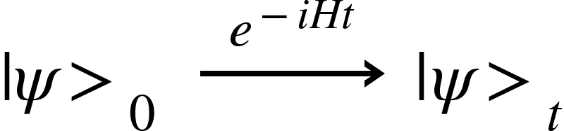 (1)**

Writing the hamiltonian for N qubit circuit:

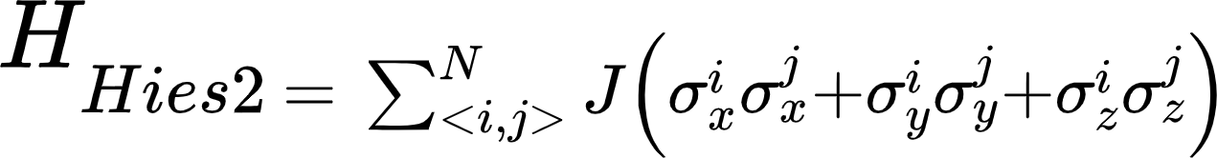

**(2)**

For N=3,

 **(3)**

Time evolving schrodinger equation(h is planck constant):

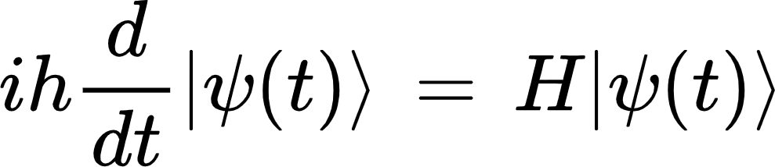 **(4)**

For ideal conditions we take h=1.We know that the Hamiltonian 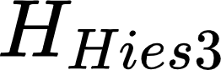 does not change in time, so the solution to the Schrödinger equation is an exponential of the Hamiltonian operator.

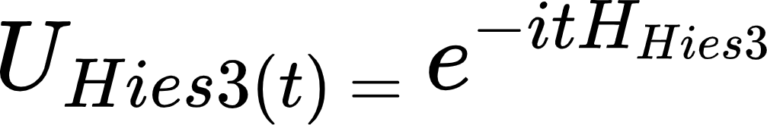 **(5)**

 **(6)**

 **(7)**

After defining our evolution hamiltonian we have to set a time period and initial state for evolution of the model here we simulate for a π time period and initial state is |110>.

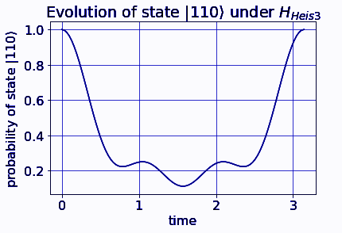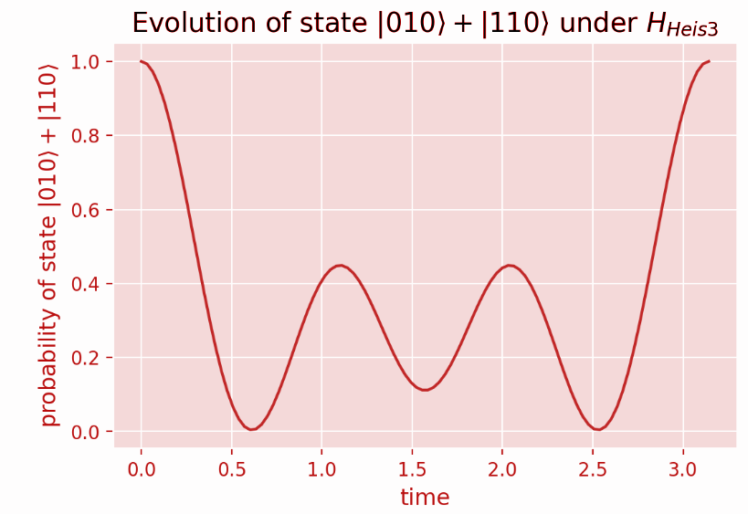

**Fig. 1**  **Fig.2**

* **We clearly see that simulation is unitary for time period pi & for any initial quantum state(Fig.1 and Fig.2).**

3. **Time Evolving Hamiltonian- Quantum Simulation**

For a time evolving circuit for Heisenberg model simulation, First we have to define a sub-circuit composed of two qubits. After that we will combine two qubit circuits in the first and second fold of three qubit main circuit using the append method(**first fold: qubits 0&1, second fold: qubits 1&2**), the main circuit represents one trotter step..

We have to use trotterization(suzuki-trotter method) for accurate simulation. The number of trotter steps we increase the simulation becomes more precise to the actual one.

Trotterization is the way we divide an equal time period for each trotter step that we take(example: time = {"font":{"color":"#000000","size":11,"family":"Arial"},"aid":null,"type":"$$","id":"11","backgroundColor":"#ffffff","code":"$$\\,\\pi$$","backgroundColorModified":false,"ts":1652903605506,"cs":"ffx8O2CRcBjV5jRn13vnyg==","size":{"width":8,"height":6}}, trotter steps=4 then each trotter gate has time {"id":"12","font":{"size":11,"color":"#000000","family":"Arial"},"aid":null,"backgroundColor":"#ffffff","code":"$$\\pi$$","type":"$$","backgroundColorModified":false,"ts":1652903619386,"cs":"dWGcD0peX+xVWjJ4waAtcA==","size":{"width":8,"height":6}}/4 to evolve). As the time period of simulation increases we have to also increase trotter steps for getting accurate results and final state fidelity.

The only restriction is that we are working on Near state devices(Noisy Quantum computers) we can’t use many trotter steps; this will also increase circuit depth and our final state fidelity will drastically decrease as compared to less number of trotter steps for the same gate. CNOT gate is the most error prone gate so our main focus is to decrease it as much as possible.

Since the pauli operators do not commute with each other, the exponential 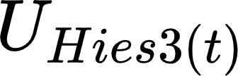 cannot be split into a product of simpler exponentials. However, we can approximate  as a product of simpler exponentials through Trotterization. Consider a subsystem of 2 spin-1/2 particles within the larger 3 spin system. The Hamiltonian on spins (i,j∈{0,1,2}) would be Rewritten eq.(2),  in terms of the two possible subsystems within the total (N=3) system you will simulate.

**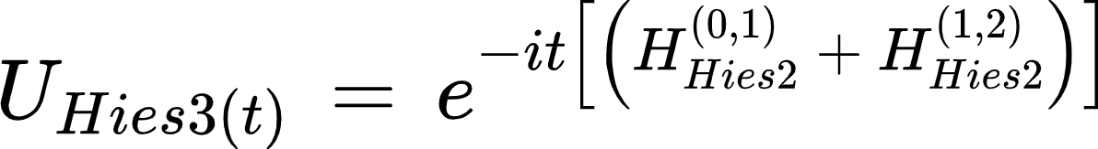 (8)**

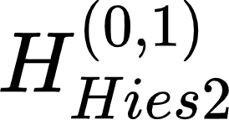 and 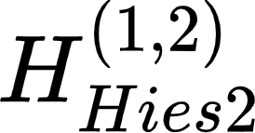 do not commute, so  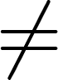 eq.(8).

But, this product decomposition can be approximated with Trotterization which says  is approximately a short evolution of {time=t/n, n is the number of trotter steps repeated n times} and followed by a short evolution of {time=t/n}.

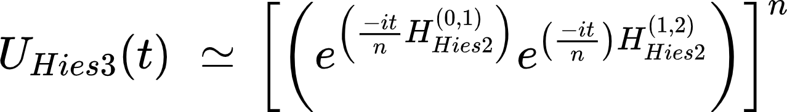 **(9)**

**n** is the number of Trotter steps, and as n increases, the approximation becomes more accurate.(Note that how a unitary is split up into subsystems for Trotterization is not necessarily unique.) The decomposition goes further. Within each 2 spin subsystems, the Pauli operator pairs 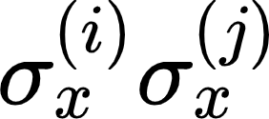, 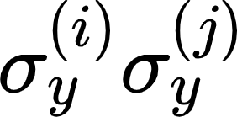and 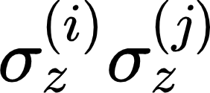commute.This means we can decompose the exponential of a subsystem Hamiltonian 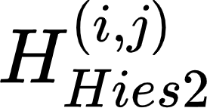 into a product of even simpler exponentials getting us closer to a gate implementation of .



**(10)**



**(11)**

For simplicity, and to use more common notation, let's rename the products with {"id":"28","font":{"color":"#000000","family":"Arial","size":11},"code":"$$XX\\left(2t\\right)=e^{\\left(-it\\sigma_{x}\\sigma_{x}\\right)},YY\\left(2t\\right)=\\,e^{\\left(-it\\sigma_{y}\\sigma_{y}\\right)}\\,and\\,ZZ\\left(\\,2t\\right)=e^{\\left(-it\\sigma_{z}\\sigma_{z}\\right)}$$","backgroundColor":"#ffffff","backgroundColorModified":false,"aid":null,"type":"$$","ts":1652908601466,"cs":"lJ/cwPQuGSLVVm0oJKcXzw==","size":{"width":460,"height":20}} now we have to rewrite the Trotterized form of 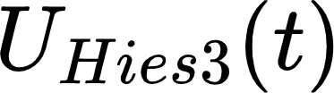.



**(12)**

**4. Sub-circuits for single fold.**

**Universal way of to define qubit rotation:**

**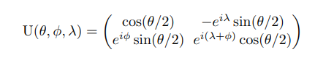**

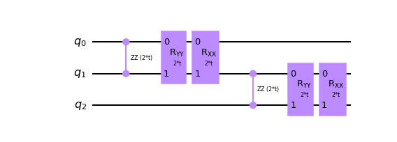

**Fig.3**

If we decompose circuit(Fig.3) to basis gates of system our trot circuit will look like for one fold:

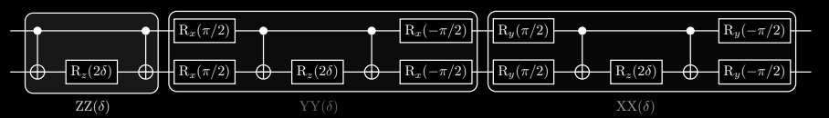

**Fig.4**

There are 6 cnots gates in one fold(Fig.4) so total 12 cnots gates are required for one trotter step for just sake if we take 10 trotter steps than total 120 cnots gates are required this will create too much noise that we can’t get fidelity more than ~40%, so either we have to optimize our circuit to reduce total numbers of cnots gates required or to use Quantum Error Correction methods for mitigating noise.

Except ZNE & CDR(Zero noise extrapolation and Clifford data regression), there is no QEC method that can improve our state fidelity for such a low value also ZNE and CDR is not a perfect way to mitigate noise it's just prediction for condition of ideal Quantum Computers with zero noise and decoherence.So here we will decrease cnots gate for final circuit and use simple readout error mitigation technique.

**5. Simulation by pulse level calibration.**

**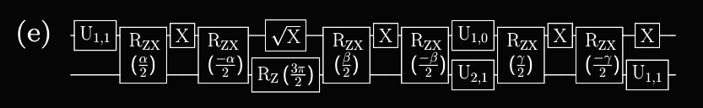**

**Fig.5**

**Pulse efficient circuit(Fig.5) by the Cartans decomposition.**

**(Fig.5), where the scaled RZX gates do not have an echo. We replaced RZ (nπ/2)√ XRZ (mπ/2) with Un,m and U1,α = RZ (π/2)√ XRZ (α) to reduce the notation and time for execution. After decomposing the circuit to RZX calibration we will use RZX calibration builder with no echo this will pretty decrease the total circuit scheduled time period for better simulation.**

**6. Circuit modification reducing cnots gates for efficient circuit**

Since the evolution operator is a unitary matrix, there is a quantum circuit that can perform this operation effectively on a quantum computer for a defined set of parameters. We'll find the quantum circuit for two spins first, then scale it up to N spins in one dimension via nearest neighbor interactions. Each spin can be mapped to a qubit, and the development of the spin system can be mapped to a quantum circuit.

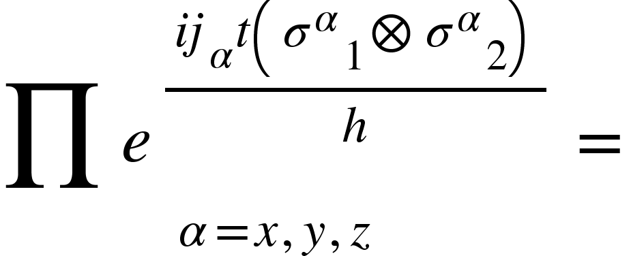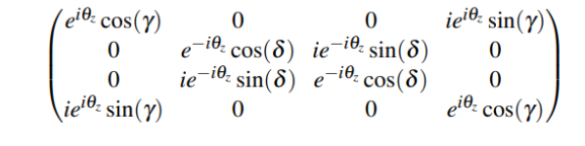

**(13)**

**In eq.(13), 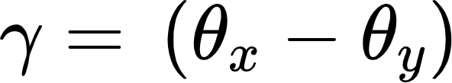 and 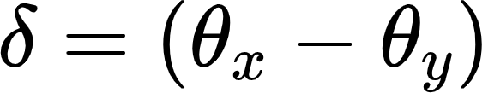.**

**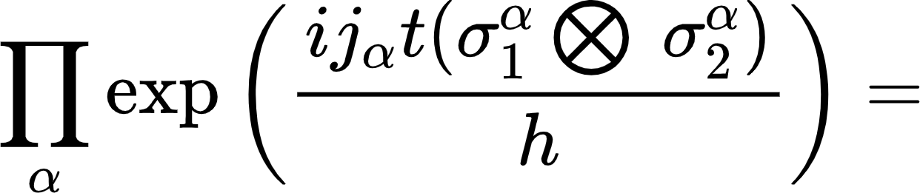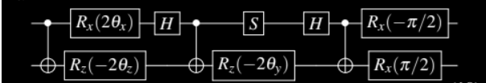**

**(14)**

**This optimized circuit has 3 cnots in one fold and total 6 cnots for one trotter step, half the numbers of cnot required as compared to original circuit, that’s not enough further we can more optimize our circuit to constant depth for independent numbers of trotter step.**

* **Using Yang Baxter equivalence method we can fold any number of trotter circuits to constant depth without changing its mechanism of hamiltonian.**
* **We will use para\_optimizer functions to work as Adam optimizer, feeding parameters and it will return updated parameters for the defined circuit.**
* **Parametric shift rule gradient descent and how it updates parameters.**
* **{More about all these processes shown in source code!}**

**In Fig.6 circuit shown without any optimization and total n trotter steps,**

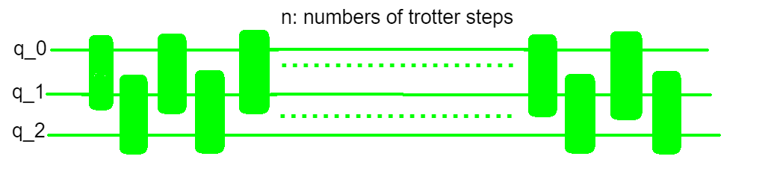

**Fig.6**

**If we fold gates using YBE(yang baxter equivalence) each fold gate with corresponding position will overlap on each other without increasing the circuit basis gates dimension. The only thing we have to update after every gate overlapping is to modify parametric gates params.**

**In Fig.7 we have shown the order, how to change the position of gates for overlapping!**

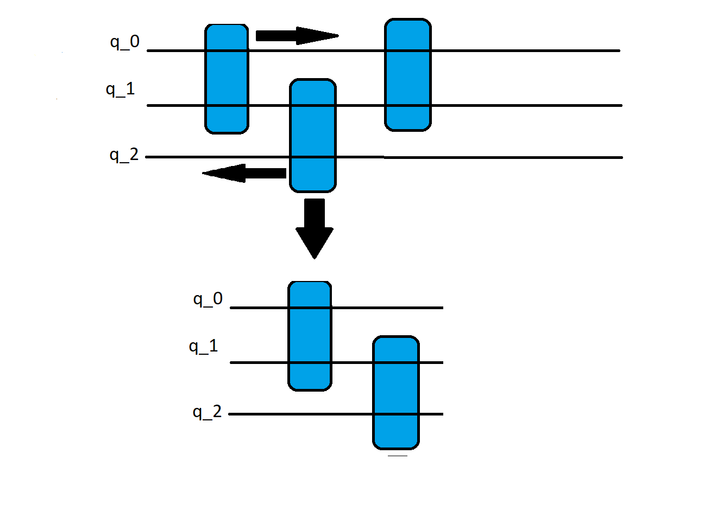**Fig.7**

**In Fig.8 final compressed circuit with 6 cnot independent of trotter steps.**

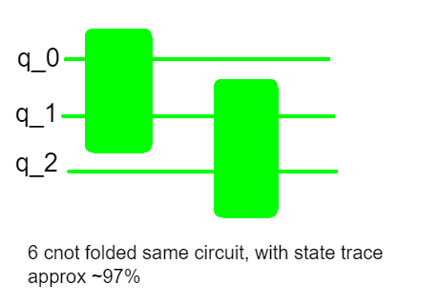

**Fig.8**

**Final optimized circuit independent of trotter steps, which takes 6 parameters for Quantum Simulation of the Heisenberg model(Fig.9).**

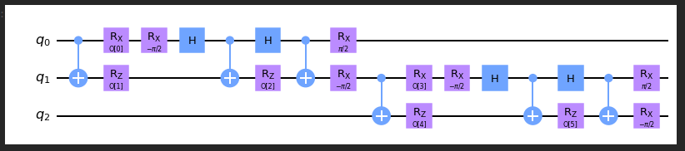

**Fig.9**

**7. Device calibration**

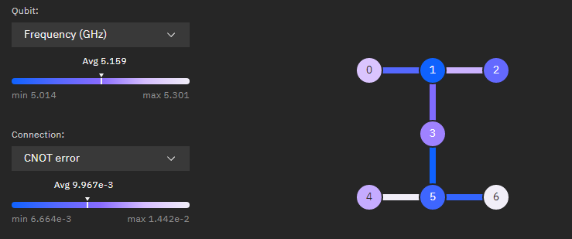

**(Fig.10, seven qubit ibmq\_jakarta calibration state and qubits layout)**

It's always better to know the device on which we want to execute our quantum circuit here we have used NISQ device ibmq\_jakata(Fig.10), using original circuit without any optimization will give state tomography fidelity approx ~40% for time period pi, for pulse optimized gate fidelity will came approx ~70%, but if we use our cnot gate optimized circuit with constant depth it will give us state fidelity approx ~90% which we further improve by applying simple QEC method-Readout error mitigation after that our final achieved state tomography fidelity will approx ~99%. More about process and practical work is provided in source code.

**REFERENCES**

1. G. Aleksandrowicz, T. Alexander, P. Barkoutsos, L. Bello, Y. Ben-Haim, D. Bucher, F. J. Cabrera-Hern´andez, J. CarballoFranquis, A. Chen, C.-F. Chen, J. M. Chow, A. D. C´orcoles-Gonzales, A. J. Cross, A. Cross, J. Cruz-Benito, C. Culver, S. D. L. P. Gonz´alez, E. D. L. Torre, D. Ding, E. Dumitrescu, I. Duran, P. Eendebak, M. Everitt, I. F. Sertage, A. Frisch, A. Fuhrer, J. Gambetta, B. G. Gago, J. Gomez-Mosquera, D. Greenberg, I. Hamamura, V. Havlicek, J. Hellmers, Lukasz Herok, H. Horii, S. Hu, T. Imamichi, T. Itoko, A. Javadi-Abhari, N. Kanazawa, A. Karazeev, K. Krsulich, P. Liu, Y. Luh, Y. Maeng, M. Marques, F. J. Mart´ın-Fern´andez, D. T. McClure, D. McKay, S. Meesala, A. Mezzacapo, N. Moll, D. M. Rodr´ıguez, G. Nannicini, P. Nation, P. Ollitrault, L. J. O’Riordan, H. Paik, J. P´erez, A. Phan, M. Pistoia, V. Prutyanov, M. Reuter, J. Rice, A. R. Davila, R. H. P. Rudy, M. Ryu, N. Sathaye, C. Schnabel, E. Schoute, K. Setia, Y. Shi, A. Silva, Y. Siraichi, S. Sivarajah, J. A. Smolin, M. Soeken, H. Takahashi, I. Tavernelli, C. Taylor, P. Taylour, K. Trabing, M. Treinish, W. Turner, D. Vogt-Lee, C. Vuillot, J. A. Wildstrom, J. Wilson, E. Winston, C. Wood, S. Wood, S. W¨orner, I. Y. Akhalwaya, and C. Zoufal, Qiskit: An Open-source Framework for Quantum Computing (2019).
2. M. Suzuki, Relationship between d-dimensional quantal spin systems and (d+1)-dimensional ising systems: Equivalence, critical exponents and systematic approximants of the partition function and spin correlations, Progress of theoretical physics 56, 1454 (1976).
3. IBM Quantum Awards: Open Science Prize 2021, https://res.cloudinary.com/ideation/image/ upload/w\_870/jug8tjgy6egm26zojyxd.pdf (2021).
4. R. Shankar, Quantum Field Theory and Condensed Matter: An Introduction (Cambridge University Press, 2017).
5. R. P. Feynman, Simulating physics with computers, Int. J. Theor. Phys 21 (1982).
6. M. Huo and Y. Li, Phys. Rev. A 105, 022427 (2022).
7. R. J. Baxter, Exactly solved models in statistical mechanics (Elsevier, 2016).
8. N. A. Sinitsyn, E. A. Yuzbashyan, V. Y. Chernyak, A. Patra, and C. Sun, Integrable time-dependent quantum hamiltonians, Physical review letters 120, 190402 (2018).
9. F. Verstraete, J. I. Cirac, and J. I. Latorre, Quantum circuits for strongly correlated quantum systems, Phys. Rev. A 79, 032316 (2009).
10. G. David, N. Guihéry, and N. Ferré, What are the physical contents of hubbard and heisenberg hamiltonian interactions extracted from broken symmetry dft calculations in magnetic compounds?, Journal of chemical theory and computation 13, 6253 (2017).
11. M. Mehta, Matrix Theory: Selected Topics and Useful Results (Hindustan Publishing Corporation, 1989).
12. M. Shiroishi, M. Takahashi, and Y. Nishiyama, Emptiness formation probability for the one-dimensional isotropic xy model, J. Phys. Soc. Jap. 70, 3535 (2001).
13. F. Franchini and A. G. Abanov, Asymptotics of toeplitz determinants and the emptiness formation probability for the XY spin chain, J. Phys. A: Math. Theor. 38, 5069 (2005).
14. A. Silva, Statistics of the work done on a quantum critical system by quenching a control parameter, Phys. Rev. Lett. 101, 120603 (2008).
15. J. Häppölä, G. B. Halász, and A. Hamma, Universality and robustness of revivals in the transverse field xy model, Phys. Rev. A 85, 032114 (2012).
16. E. Barouch, B. M. McCoy, and M. Dresden, Statistical mechanics of the XY model. i, Phys. Rev. A 2, 1075 (1970).
17. F. Franchini, An Introduction to Integrable Techniques for One-Dimensional Quantum Systems, Lecture Notes in Physics (Springer International Publishing, 2017).
18. J. A. Smolin, J. M. Gambetta, and G. Smith, Phys. Rev. Lett. 108, 070502 (2012).
19. N. F. Berthusen, T. V. Trevisan, T. Iadecola, and P. P. Orth, Quantum dynamics simulations beyond the coherence time on nisq hardware by variational trotter compression (2021).
20. R. LaRose, A. Mari, N. Shammah, P. Karalekas, and W. Zeng, Mitiq: A software package for error mitigation on near-term quantum computers, https://github.com/unitaryfund/mitiq (2020).
21. T. Giurgica-Tiron, Y. Hindy, R. LaRose, A. Mari, and W. J. Zeng, in 2020 IEEE International Conference on Quantum Computing and Engineering (QCE) (IEEE, 2020).
22. G. Mussardo, Statistical Field Theory: An Introduction to Exactly Solved Models in Statistical Physics, Oxford Graduate Texts (OUP Oxford, 2010).
23. F. A. Vind, A. Foerster, I. S. Oliveira, R. S. Sarthour, D. d. O. Soares-Pinto, A. M. d. Souza, and I. Roditi, Experimental realization of the yang-baxter equation via nmr interferometry, Scientific reports 6, 1 (2016).
24. L. H. Kauffman and S. J. J. Lomonaco, Topological quantum information theory, in Proceedings of Symposia in Applied Mathematics, Vol. 68, edited by S. J. Lomonaco (AMS, Washington DC, 2010).
25. Y. Zhang, Integrable quantum computation, Quantum Inf. Process. 12, 631 (2013).
26. S. Gulania, B. Peng, and N. Govind, Reflection symmetry in quantum circuits following the Yang-Baxter equation, In preparation.
27. M.-L. Ge, K. Xue, R.-Y. Zhang, and Q. Zhao, Yang–Baxter equations and quantum entanglements, Quantum Inf. Process. 15, 5211 (2016).